

WEDE5020 poe

ST10380113



May 29, 2023

hIRANYA RAMLACKAN

Table of Contents

Part 1 ……………………………………………………………………………………………………………….…………………….. Pg. 1-9

Website choice …………………………………………………………..……….. Pg. 2

Website assets …………………………………………………………………. Pg. 3-7

Logo and Home page ………………………………………………………………………………. Pg. 3-4

About us page …………………………………………………………………..……………………. Pg. 5-6

Services page …………………………………………………………………………………………... Pg. 6-7

Donation page …………………………………………………………………………………………… Pg. 7

Website pages and content ………………………………….………………….. Pg. 8

Reference ………………………………………………………………………... Pg. 9

Part 2 ……………………………………………………………………………………………………………….…………………….. Pg. 10

Improvements to the process document ….……………………..……….. Pg. 11-15

Website pages and content improvement ……………………..…….…………….. Pg. 11-13

Website assets improvement ………………………………………………………………. Pg. 13-15

Improvements to the website ….………...…………………………..……….. Pg. 16

Website choice

Verulam Day and Frail Care Centre

The Verulam Day and Frail Care Centre, is a non-profit organisation situated in Brindhaven in Verulam, north of Durban. The organisation was established in 1983 to give elderly people a place to feel at peace and in a tranquil environment.

They provide the terminally ill with care and support, including end of life respite and palliative care for the patient as well as counselling, care and support services for their families. They offer an inpatient frail care facility free of charge as well as an outpatient day-care centre for older persons.

Other services offered by the centre includes a home-based care service for people who are unable to travel to the centre, as well as provides a meals-on-wheels programme for the elderly. This organisation operates 24 hours, 7 days a week to provide an immediate help response to elderly people.

Having viewed the Verulam Day and Frail Care Centre’s website, in my opinion it lacks appeal. Unlike some other NPO websites, this one fails to tell a compelling story of the work being done by the organisation. Their source of funding is primarily based on donations and sponsorships. Although, with the help of this website my idea is to make it easier for the public to donate by allowing them to donate directly via the website which is a vital part to any non-profit organisation’s web page. Their website also does not provide stats on the number of people they support and are able to care for, an option for volunteers. It is also not updated regularly in terms of the work they do or their fundraising initiatives.

Having viewed other NPO websites and those of charitable organisations, I believe I could create a more appealing and user-friendly website that would attract potential donors and volunteers.

Website assets

Logo:

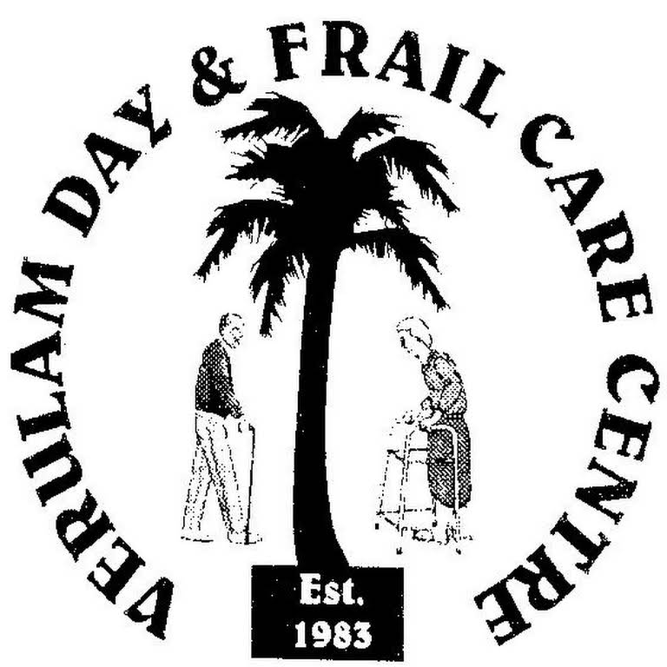

Home page:

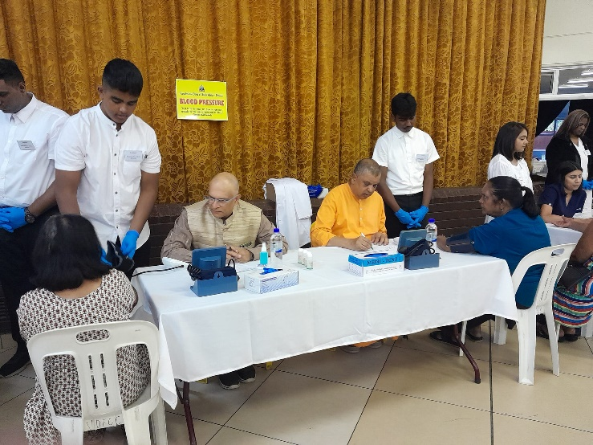

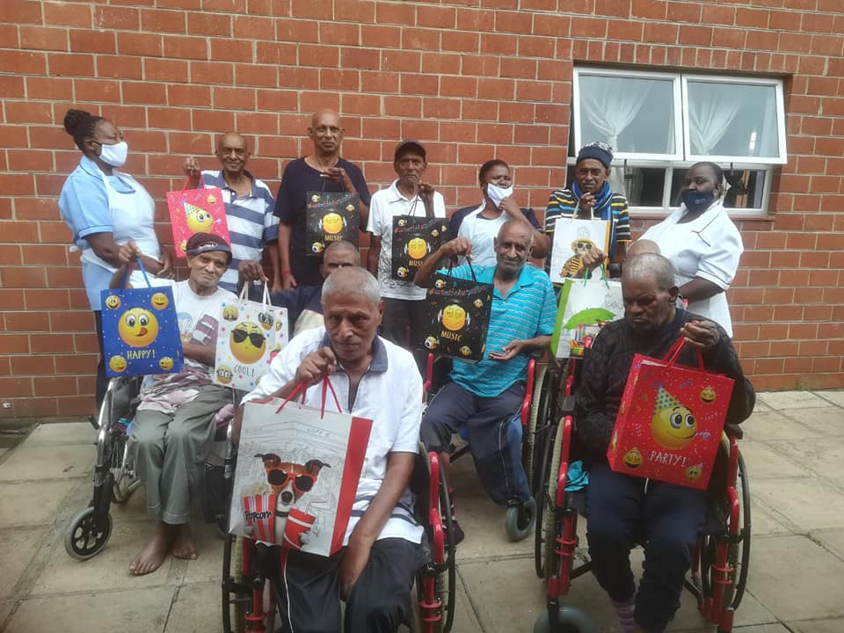

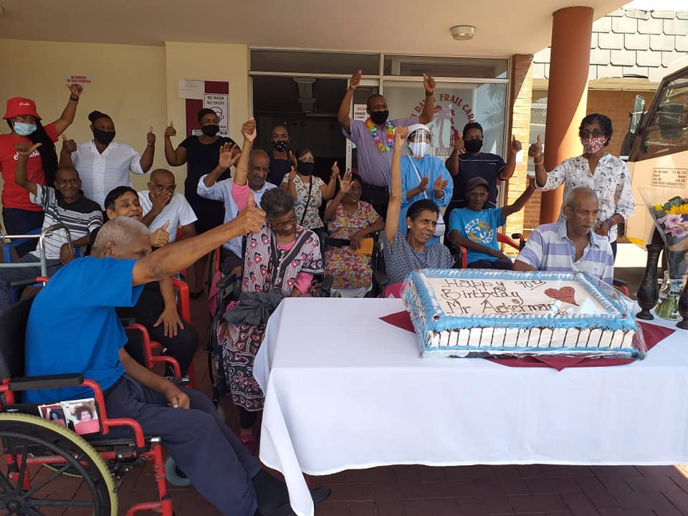

About us page:

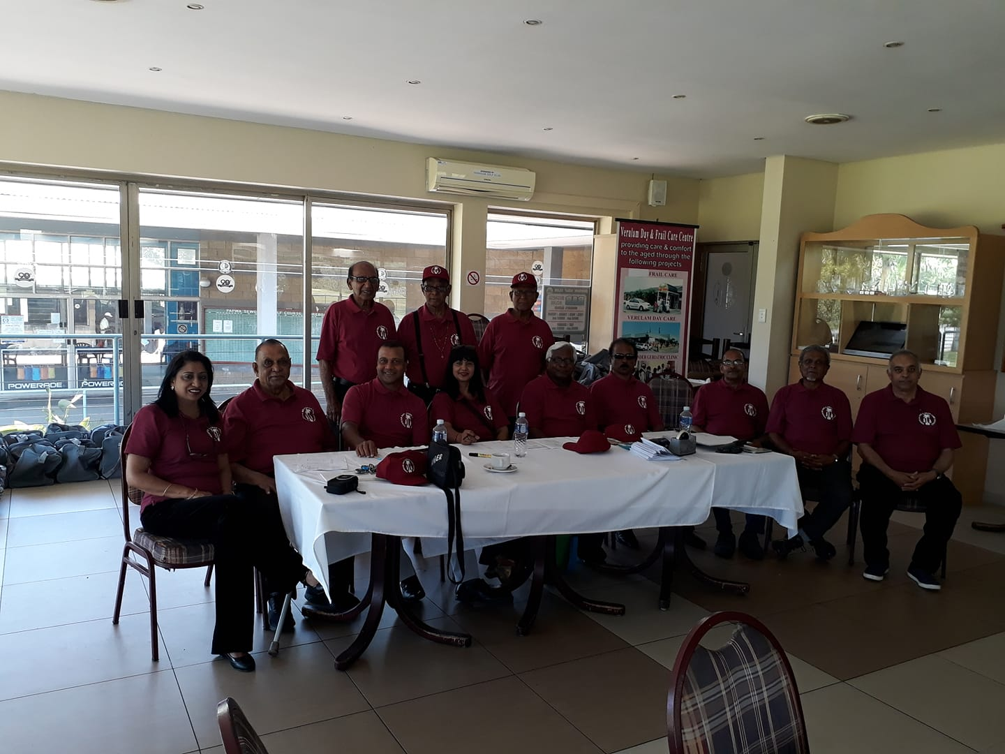

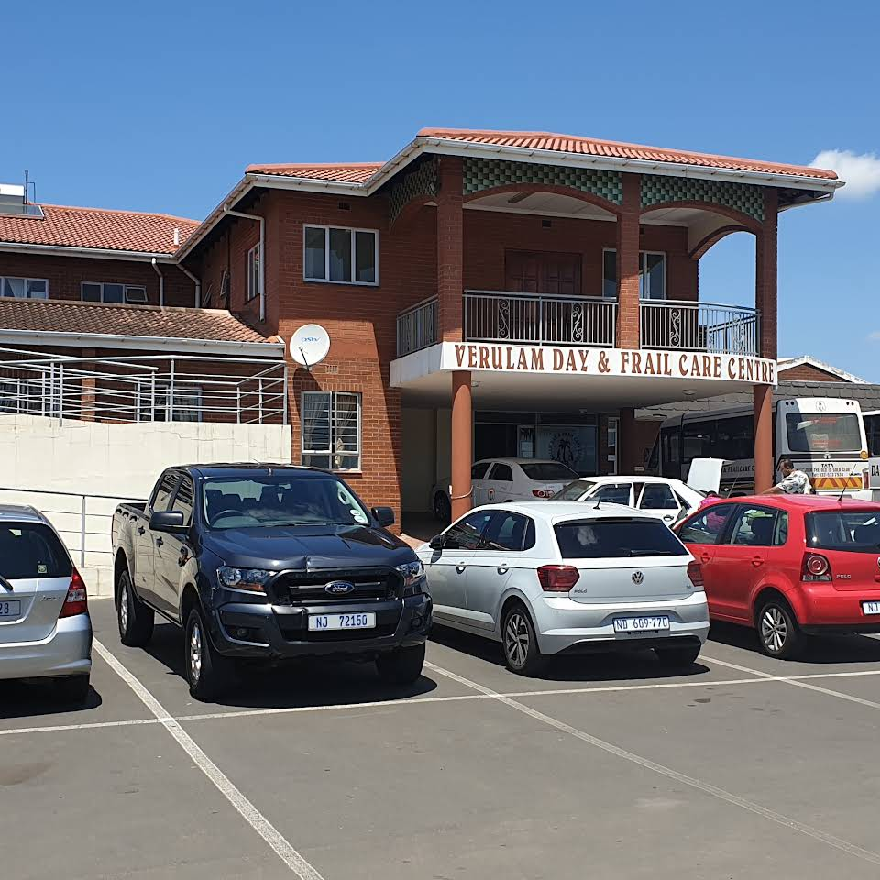

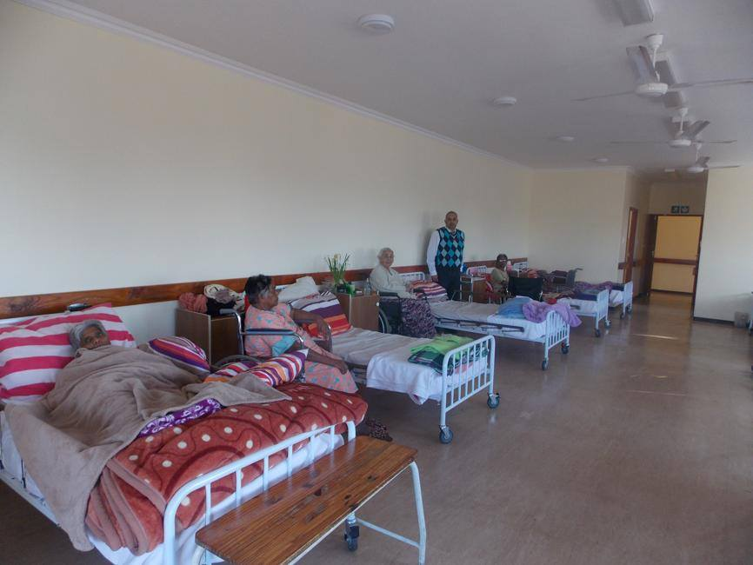

Services page:

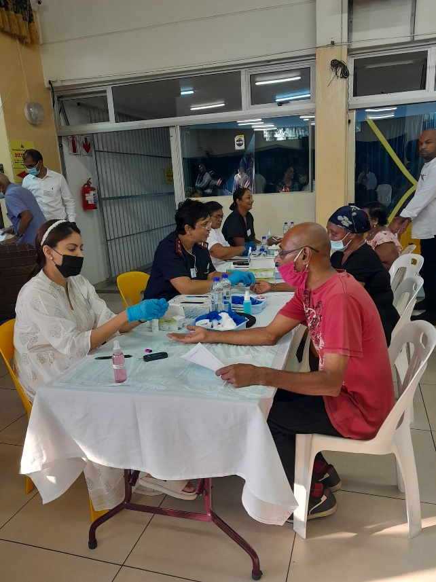

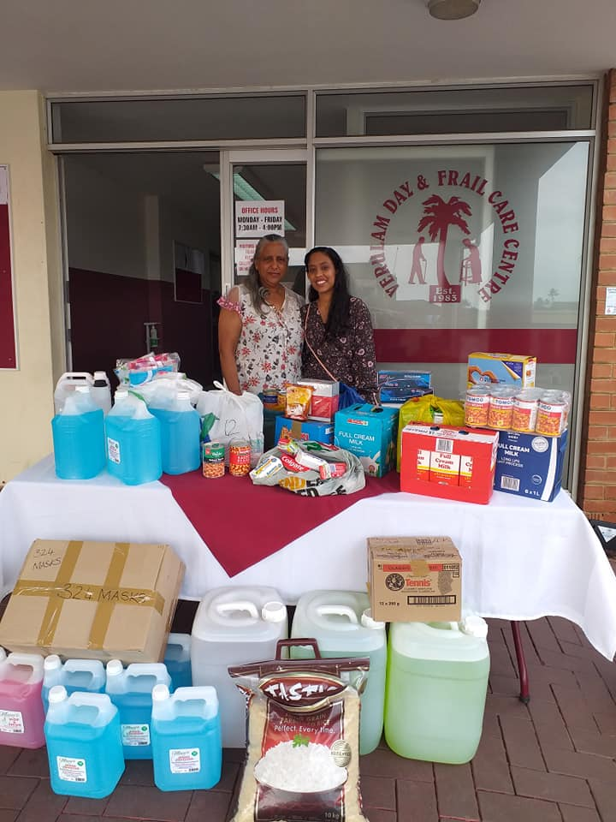

Donation page:

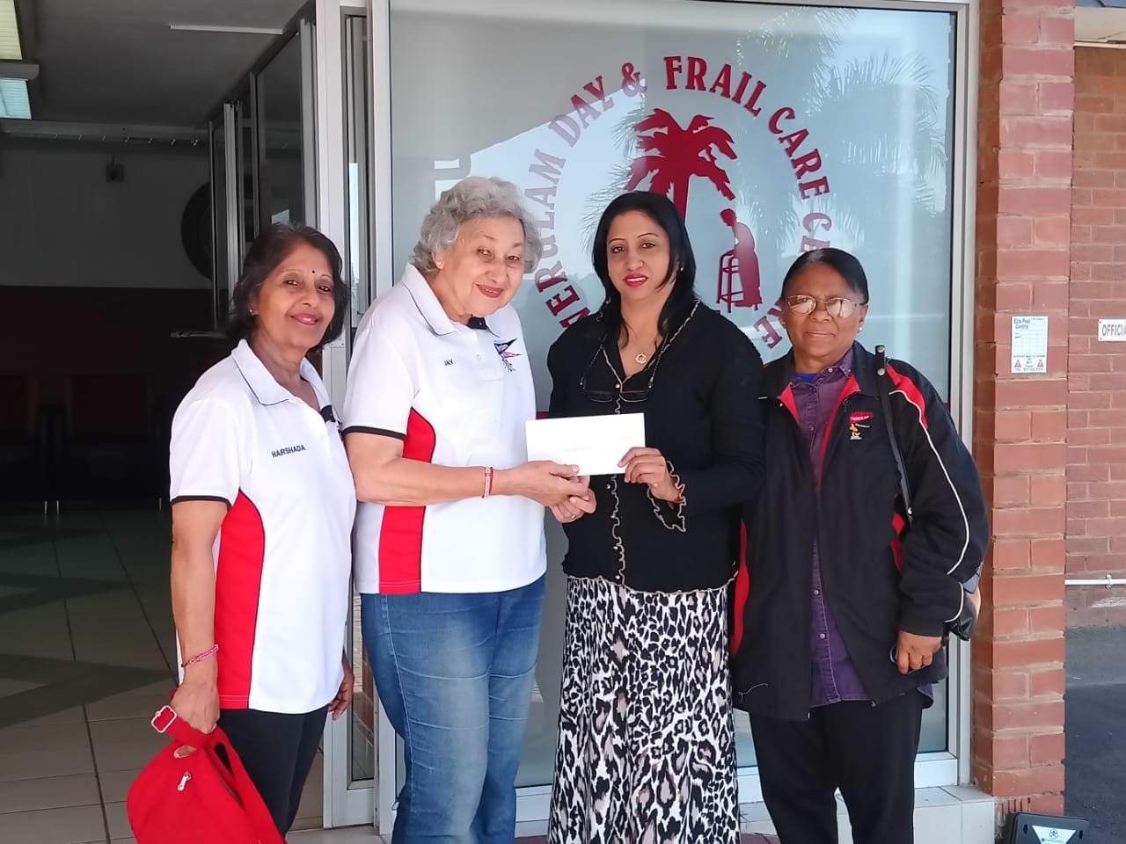

Website Pages and Content

1. Home page
   1. Logo
   2. Pictures
   3. Brief explanation of the organisations history and the services they offer together with the links to the respective pages.
   4. Contact details
   5. Fundraising events
   6. Copyright / year
2. About us
   1. Picture of the organisations building
   2. Picture of the organisations team
   3. The NPOs history
   4. Vision and mission of the organisation
3. Contact page
   1. Telephone and cell phone number
   2. Email address
   3. Address
   4. Managers details
4. Services
   1. Pictures
   2. Explanation of each service offered by the NPO.
5. Donation
   1. Information if people wish to be a volunteer.
   2. Information on how to make a cash donation.

References

(no date) *Aryan Benevolent Home*. Available at: https://abh.org.za/ (Accessed: March 28, 2023).

*Verulam Day & Frail Care Centre established in 1983* (no date) *Community Chest Durban*. Available at: https://www.communitychest.co.za/post/verulam-day-frail-care-centre (Accessed: March 29, 2023).

*Verulam Day and Frail Care Centre* (no date) *Non-Profit Organization in Brindhaven*. Available at: https://verulam-day-and-frail-care.business.site/ (Accessed: March 29, 2023).

WEDE5020 poe

ST10380113

May 29, 2023

hIRANYA RAMLACKAN

Improvements to Part 1

Process document

**Website pages and content from part 1:**

1. Home page
   1. Logo
   2. Pictures
   3. Brief explanation of the organisations history and the services they offer together with the links to the respective pages.
   4. Contact details
   5. Fundraising events
   6. Copyright / year
2. About us
   1. Picture of the organisations building
   2. Picture of the organisations team
   3. The NPOs history
   4. Vision and mission of the organisation
3. Contact page
   1. Telephone and cell phone number
   2. Email address
   3. Address
   4. Managers details
4. Services
   1. Pictures
   2. Explanation of each service offered by the NPO.
5. Donation
   1. Information if people wish to be a volunteer.
   2. Information on how to make a cash donation.

**Website pages and content improvements on part 1:**

1. Home page
   1. Logo
   2. Navigation bar with links to the service page, about us page, contact us page, donation page and gallery page.
   3. The first picture is of a medical drive that was conducted at the Verulam Day and Frail Care Centre.
   4. The second picture is of all the elderly people gathered enjoying each other’s company.
   5. The third picture is of the elderly people receiving gifts.
   6. Brief explanation of the organisations history and the services they offer together with the links to the respective pages.
   7. The important or more commonly used contact details with a button that gives the user access to the contact page.
   8. A list of the different fundraising events hosted by the Verulam Day and Frail Care Centre.
   9. A footer with “Verulam Day and Frail Care Centre”, the year it was established and the email address.
2. Services
   1. Logo
   2. Navigation bar with links to the home page, about us page, contact us page, donation page and gallery page.
   3. The first picture is of a medical drive that was conducted at the Verulam Day and Frail Care Centre.
   4. The second and third picture is of food and other goods gifted to the organisation to be used by the elderly.
   5. All the services offered by the organisation is explained.
   6. A footer with “Verulam Day and Frail Care Centre”, the year it was established and the email address.
3. About us
   1. Logo
   2. Navigation bar with links to the home page, service page, contact us page, donation page and gallery page.
   3. The first and third picture is of the Verulam Day and Frail Care Centre’s management team.
   4. The second picture is of the Verulam Day and Frail Care Centre’s building.
   5. The history behind the Verulam Day and Frail Care Centre is provided.
   6. Lastly, the Vision and mission of the Verulam Day and Frail Care Centre established.
   7. A footer with “Verulam Day and Frail Care Centre”, the year it was established and the email address.
4. Contact page
   1. Logo
   2. Navigation bar with links to the home page, service page, about us page, donation page and gallery page.
   3. Telephone and cell phone number
   4. Email address
   5. Address
   6. Managers details
   7. A footer with “Verulam Day and Frail Care Centre”, the year it was established and the email address.
5. Donation
   1. Logo
   2. Navigation bar with links to the home page, service page, about us page, contact us page and gallery page.
   3. The first two pictures show local school students volunteering their services at the organisation.
   4. The third picture shows people giving a donation towards the organisation.
   5. If someone wishes to volunteer their services to the organisation, the information regarding how they do so is provided.
   6. If someone wishes to donate to the organisation, the information regarding how they do so is provided.
   7. A footer with “Verulam Day and Frail Care Centre”, the year it was established and the email address.

(Added)

1. Gallery
   1. Logo
   2. Navigation bar with links to the home page, service page, about us page, contact us page and donation page.
   3. A video compilation of different pictures of the organisation.
   4. A footer with “Verulam Day and Frail Care Centre”, the year it was established and the email address.

**Website assets improvements on part 1:**

Gallery

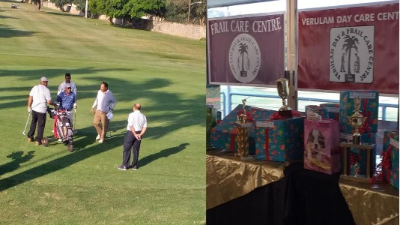

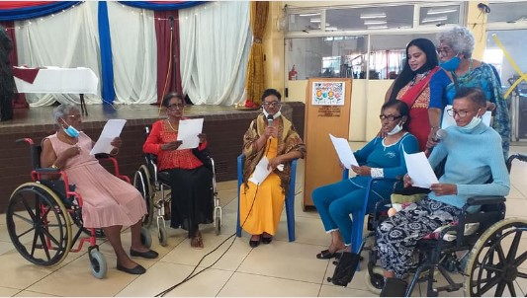

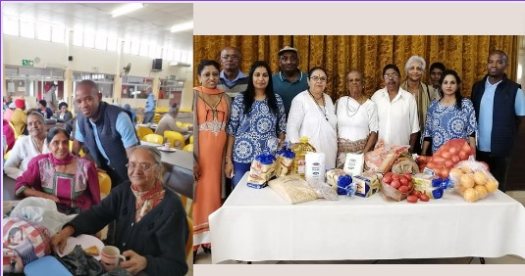

Improvements to Part 1

Website

Background colour of all pages at its maximum width is changed from white to black.

When the width of the page is decreased the background colour changes from black to white.

All font colour, when the page is at maximum width, is changed from black to white.

When the width of the page is then decreased, the font colour is changed back to black from white.

The font size of all the paragraphs on the website was increased to 30px, to create uniformity.

The font size of all the li on the website was changed to 30px, to create uniformity.

The font size of all the h1 on the website was changed to 35px, to create uniformity.

The font size of all the h2 on the website was changed to 30px, to create uniformity.

Created a gallery page with a video (line 36 - 40).

Added the gallery page to the navigation bar.

Decreased the width of the navigation bar on the services, about us, contact us and donation page.

Removed services from the navigation bar on the services page.

Removed about us from the navigation bar on the about us page.

Removed contact us from the navigation bar on the contact us page.

Removed donation from the navigation bar on the donation page.

Centralised the information in the services section on the home page to the centre of the page.

All the pictures on the website have a max-width of 100% to allow it to be compatible on any device.

The colour of the navigation bar and the footer was changed from black to a pink colour.

Comments to the code are added.